Who are we looking for?

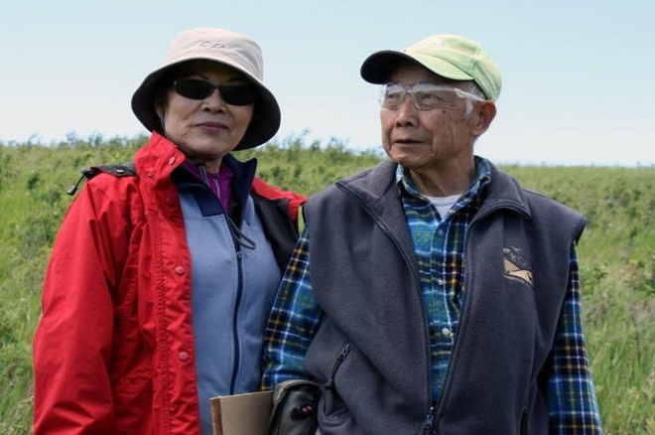
Volunteers Yvonne Yoon and Dick Choy

Our volunteers range in age and come from a variety of backgrounds. We are looking for the following from new volunteers.

- People with an interest in nature and conservation
- People who are willing to learn and grow - you don’t need a background in biology – you just must be willing to learn
- People willing to make a commitment – (varies depending on volunteer role)

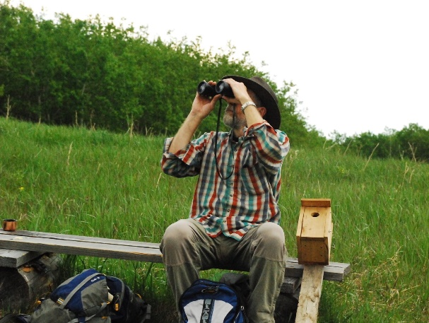
Steward Volunteer Bruno Arnold
About the ASCCA

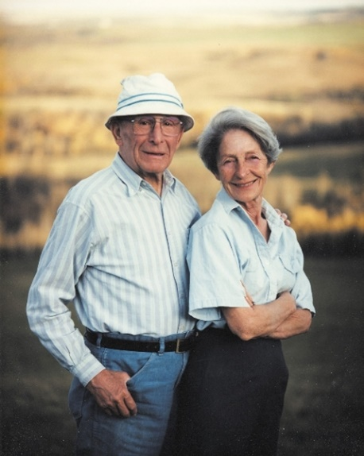
Donors Ann and Sandy Cross

The Ann & Sandy Cross Conservation Area is 4800 acres of rolling foothills comprised of grassland and aspen forest. The land was donated to the province of Alberta by Sandy Cross and his wife Ann, in 1987. At the time, this was the largest private land donation in Canadian history.

The Ann & Sandy Cross Conservation Area as a non-profit was formed in 1996.

- We protect habitat and provide space for native species of wildlife
- We offer conservation education programs, particularly for young people, without negatively impacting wildlife and habitat
- We manage human use of the ASCCA through entry by registration and other techniques
Volunteer with the Ann & Sandy Cross Conservation Area

Thank you for your interest in volunteering with the Ann & Sandy Cross Conservation Area (ASCCA).

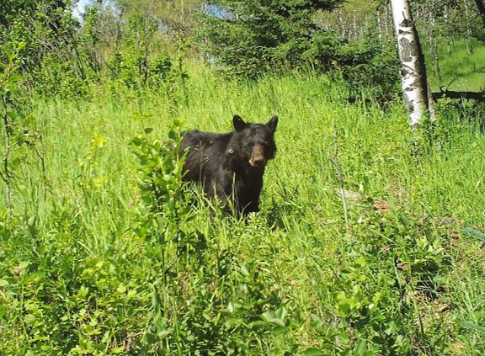
Black bear photographed by our wildlife camera

Since our volunteer program began in 1992, volunteers have been the life of the Ann & Sandy Cross Conservation Area. We have around 80 active volunteers. In 2016 they volunteered over 4000 hours!

Interested in learning more? Contact us!

Anna Aldridge, Volunteer Coordinator
E: info@crossconservation.org
P: 403.931.1042

http://www.crossconservation.org
@ASCConservation (Twitter + Facebook)

Volunteer Roles

This brochure provides a brief overview of our main volunteer positions. Area Steward, Special Projects, Education and Special Events. ASCCA volunteers may be involved in multiple capacities, and new opportunities to be involved often present themselves.

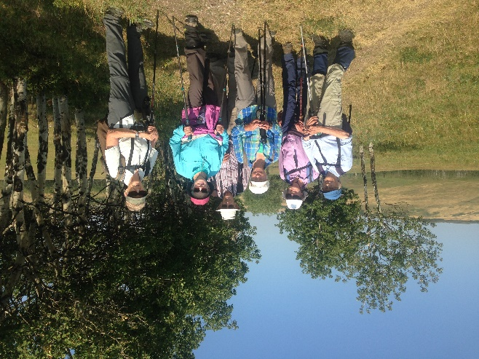
Area Steward Volunteers

Area Steward
- Attend regular hikes, or area patrols in the area with a partner, depending on when they are available.
- Check vehicles in the parking lot, speak with visitors, and act as ambassadors for the ASCCA.
- Keep the area safe by reporting incidents and wildlife sightings.

Police check required.
Recommended 8 patrols/year.
New stewards must attend training and shadowing, as well as an interview.
Education
- People who love kids and the outdoors, have good communication skills, and are physically active.
- Assist our education staff in delivering programs to students.
- Must have weekday availability (Monday – Friday)

Police check required.
First aid required.
New educator volunteers must attend training and shadowing, as well as an interview with education staff.

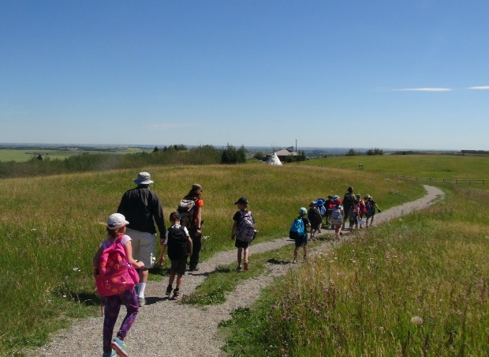
Leading a group of children

Special Projects
- Area projects completed by a team
- May involve landscaping, gardening, trail/area/building maintenance, fencing and invasive weed removal.

Police check required.
Related experience preferred.
Must meet with habitat manager and shadow at least one work day.
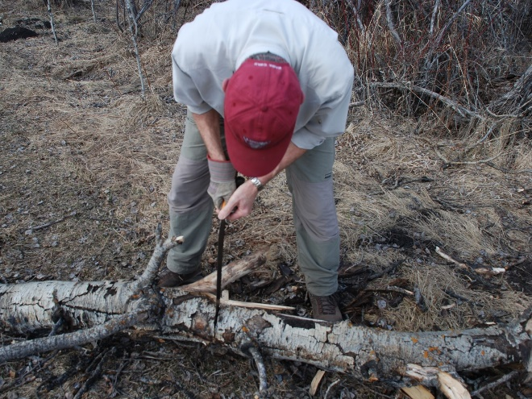
Special Projects Volunteering

Special Events
- Assist with set up, registration and activities taking place during events
- Represent the ASCCA at various fairs and community events
- Availability evenings and weekends (some weekdays depend on event)

Police check required.
Must attend an interview.

Next Steps?

1. Attend Volunteer Recruitment Session in March and Area Steward Training in April (if you would like to be a steward).
2. Complete a Volunteer Application (available from our website)
3. Schedule an Interview
4. Shadowing, Training, Evaluation
5. Volunteer!

